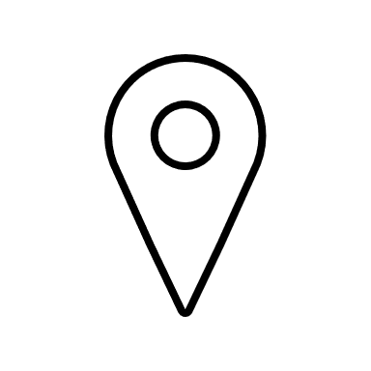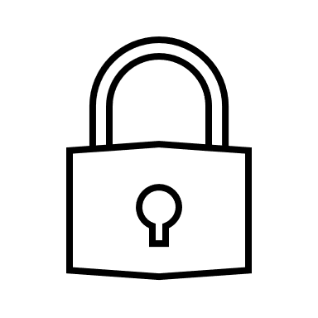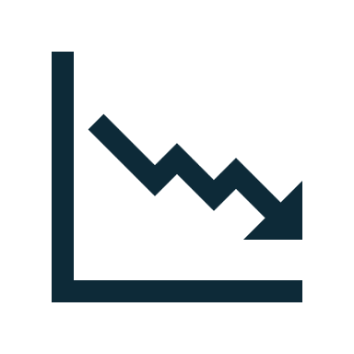

**Our Solution**  
Software that records all records relating to a device.

**Our Mission**

Providing a seamless, scalable software solution for managing and tracking IoT device lifecycles, ensuring security, traceability, sustainability, and ease of use.

**Benefits**

IoT Lifecycle Manager

Complete Lifecycle Management of IoT Devices from Deployment to Recycling

Benefit From complete record of actions for all devices, for a lower cost of ownership

Complete Device Lifecycle History

Asset Locating / Accountability

Improved Installation & Maintenance

Reduction in Operation Costs

Improved Security

Reduces E-Waste

**Your t**